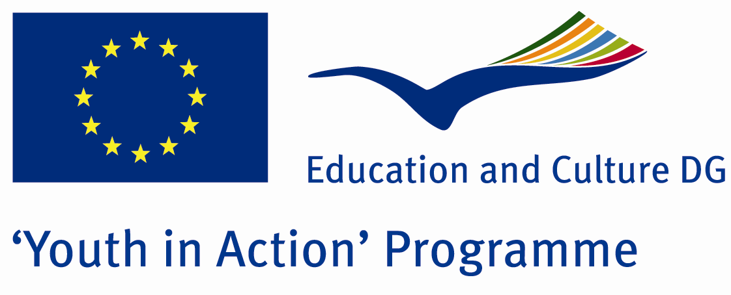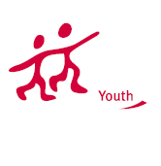

Action 1,1
Project Summary; Global warming is getting bigger problem for whole humanity.To give a good world to the new generations we must do our best.In this Project we are planing to take some important steps such as cropping saplings , shoting a short film with local people , showing some movies and videos about global warming.There will be welcome party,ice-breakers,seminars,workshops,culture nights and more.Participants will be having fun while they do these things and after the Project, participants will be able to answer these questions “What can we do ? , if we don’t do anything what will happen ? , what should we do ? , How can we keep our aim ?. Furthermore , participants will have talked about their cultures , countries after the Project so they will learn how to be a part of europe.In our workshops , participant will work together and they will learn different opinions.In summary , our Project will be in a theme with environment and brotherhood .

Project Title; THE EARTH IS ON FIRE
Date and Venue ; 17-24 JULY BAYBURT/TURKEY

Target Group ; Municipalities, City Councils and Non-Governmental organizations,
youth groups,culture and art groups,e.t.c

Participants ; 5 people from each country (over 18 -25 ). Totally 8 countries.

Conditions ; Accommodation, board and programme costs will be financed through European Commission Youth in Action Programme . Travel costs will be reimbursed in 70% (APEX Tarrifs). Organizations from all 27 EU member countries plus Liechtenstein , Norway and Iceland are eligible to take part.

Working language: English

Organisator group:HAN SANAT GRUBU

How to apply: If you are interested, please send your Part III forms to
by e-mail please (in word file). Scan Part3 format is enough for application.(Fulfilled Part III which you can find in the attachment, of course signed and stamped) ..

Contact e-mail: hansanatgrubu@gmail.com

Deadline: 10th October 2011

